Casper User Manual
Table of Contents – PART 3: Casper eCommerce
PART 3: CASPER eCOMMERCE
Chapter 1: eCommerce Overview 179
In this Chapter 179
Casper eCommerce Functionality 179
Client Wizard 180
Prerequisites 181
Chapter 2: Testing eCommerce 183
In this Chapter 183
Chapter 3: Managing eCommerce 187
Online Payment Processing 187
Admin menu 188
Exchange Rate 188
System Maintenance menu 190
E-Receipt 191
Credit Card Authorization 194
Fraud Protection 197
Tax Calculations 199
Chapter 4: eCommerce Reports 201
Index 205

List of Tables
Table 3-1: Exchange Rate – Data Entry Fields 189
Table 3-2: E-Receipt – Data Entry Fields 192
Table 3-3: Credit Card – Data Entry Fields 195

List of Figures
Figure 1-1 Electronic Purchase Wizard – eCommerce option 180
Figure 3-1 Exchange Rate screen 189
Figure 3-2 New Exchange Rate 190
Figure 3-3 System Maintenance – E-Receipt page 192
Figure 3-4 Sample e-Receipt 194
Figure 3-5 Credit Card screen 195
Figure 3-6 System Maintenance – Fraud Protection page 198
Figure 3-7 System Maintenance – Taxes page 199
Figure 4-1 Reports screen 201
Figure 4-1 Sales by Day Report 202
Figure 4-2 Sales by Week Report 203

Chapter 1: eCommerce Overview
Casper eCommerce offers an alternative way to allow your customers to pay.
C
asper eCommerce issues licenses based on approval of payment using the customer’s credit card number processed by third-party software.

In this Chapter
In this chapter you will find information on enabling Casper’s eCommerce feature. The Casper eCommerce option allows you to process customer transactions using credit card authorization. (For details of licensing software purchases using Serial Numbers instead of or as well as credit cards, see Part 2: Casper eRegister).
Note: You must have purchased the eCommerce version of Casper before you can use this feature.

Casper eCommerce Functionality
In the Casper eCommerce option, Casper issues a Site Key based on approval of payment by credit card. The approval is obtained through third-party software–if you purchased the Casper eCommerce version of Casper, CrypKey provides PC Charge® as the payment gateway. Casper also supports Payflow Pro® and ParaData.
Casper eCommerce allows you to perform the following functions:
- issue licenses for your software to customers paying by credit card
- authorize credit card purchases (see Credit Card Authorization on page 194).
- send an internal e-receipt to notify you when the purchase authorization has taken place (see E-Receipt on page 191).
- enable fraud protection (see Fraud Protection on page 197).
- calculate sales and country taxes (see Tax on page 199).
Note: You can specify a price for the Product Code (see Part 2: Casper eRegister, Add Product Codes using the Product Code Browser).
Product Codes represent an important feature of the automated license-issuing process. When the Casper Server processes license requests involving credit card transactions, it accesses the Product Codes in CasperWeb to determine license restrictions and pricing.

Client Wizard
The Electronic Purchase Wizard (on the Client side) will look different to a Customer when using the eCommerce option than when using the eRegister option (see Part 2: Casper eRegister). The Wizard for eCommerce will include fields for the credit card information, product code and price, as follows:
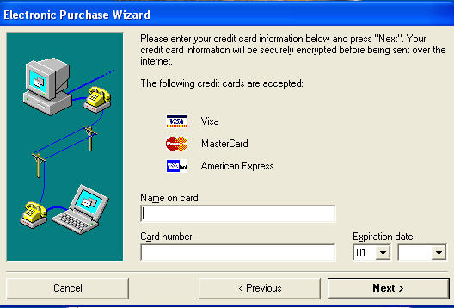
Figure 1-1 Electronic Purchase Wizard – eCommerce option

Prerequisites
- In order to use Casper eCommerce you will need an Internet connection and SMTP email service.
- See Part 1: Setting Up Casper for a complete list of prerequisites needed to use Casper.

Chapter 2: Testing eCommerce
Before going live with Casper eCommerce, CrypKey recommends that you test your data.
I
t’s a necessary precaution to test the functionality of Casper modules before using them in a live customer situation. The functionality of Casper eCommerce is somewhat different from Casper eRegister (particularly on the Client side), and needs to be tested separately.
In addition to the following test for Casper eCommerce, you should first perform the standard company data tests in Part 2: Casper eRegister.

In this Chapter
In this chapter you will find information on:
- Testing Casper eCommerce using company data
Procedure - Casper Credit Card Processing: Setup and Testing
This section details the steps to configure your server to process credit card transactions using CasperWeb, and the testing process to verify everything is working correctly.
- Install PCCharge Payment Gateway. You will receive a CD from CrypKey, containing PCCharge software, which Casper users to process credit card transactions.
- Verify that you have been provided with a fairly current version of PCCharge Payment Gateway. Check the Go Software website to see what the current version is, at www.gosoftware.com. If you do not have a current version, let your CrypKey account manager know and we will get the correct version to you.
- Install the PCCharge software on your Casper Server.
- Configure PCCharge
For assistance: call Go Software at: 1-877-659-8981. Your PCCharge software comes with 60 days of support from Go Software. Note that the steps below may vary between different versions of PCCharge. For assistance, please contact Go Software.
- You will need the setup information from your credit card processor. It should include the following information:
- Merchant ID 12 characters
- Acquirer/Bank ID (BIN) 6 characters
- Store Number 4 characters
- Terminal Number 4 characters
- Country Code 840 = US
- Merchant Zip Code 5 digits
- Time Zone PST (708), EST(705), CST(706), MNT(707)
- Category Code (SIC, MCC) 4 characters
- Merchant Business Name
- Merchant Phone Number
- Merchant State
- Merchant Location Number 5 characters
- Agent ID 6 digits
- Chain Number 6 digits
- V Number 8 digits
- Start PCCharge – an icon will appear in the system tray. Double-click on the icon to display the PCCharge main screen.
- Configure a password for the SYSTEM account.
- Start the merchant setup wizard.
- Select the credit card processing company and click ADD.
- Enter the Serial Number (provided by CrypKey with your purchase).
- Select the credit card processor (again).
- Enter the Merchant ID and click OK.
- Contact Go Software (1-877-659-8981 option #1) to get a security code that you will need to complete the process. The Go software rep will walk you through the rest of the configuration steps and test the installation. Note the credit card number and expiry date used for testing, as you can use it to test the Casper transaction later; for example:
VISA 4012888888881 Exp 1208
- Once the configuration is complete, create a configuration disk which you can use to restore the PCCharge configuration if it is ever required. See the help contents installed with PCCharge for more information.
- Configure CasperWeb for Credit Card Processing:
- Log on to CasperWeb and configure the e-Receipt that your customers will receive by email when they make a credit card purchase. The e-Receipt function is located in the System Maintenance screen page 2. Note that the message should contain <data> tag, which Casper will use to insert transaction details when the message is sent to the end user. The notification email is the email of the person at YOUR company, who will receive a copy of the receipt every time there is a sale. See the E-Receipt section on page 191 for more details on this subject.
- In the System Maintenance screen, page 4, you can input all your credit card settings required by Casper. See Credit Card Authorization on page 194.
- Test Credit Card Transaction:
Run the CaspTest.exe program using your Casper URL. You should be able to test credit card processing using the TESTING product code.
Chapter 3: Managing eCommerce
Casper eCommerce offers the flexibility to accept payment from customers using secure credit card authorization.
T
his chapter describes how to configure the Casper Server for credit card processing.
In this chapter you will find information about:
- PCCharge®
- Payflow Pro®
- E-Receipts
- credit card authorization
- fraud protection
- taxes

Online Payment Processing
The Server uses one of the following charge methods to process credit card payment transactions (in support of customers' license authorization requests):
- The PCCharge module—also known as ActiveCharge— is an optional feature of Casper. In order to use the module, you must obtain and install additional software from the maker of PCCharge. To find out more about the PCCharge software, go to the website www.gosoftinc.com. To use PCCharge, you must set up a merchant account with one of the banks or service providers supported by PCCharge.
- ParaData – Casper also supports this online payment processing software. To find out more, go to the website www.paradata.com.
- Payflow Pro – Casper also supports this online payment processing software. To find out more, go to the website www.verisign.com.
The Server determines the price (if specified) of the license purchase from its Product Code record in CasperWeb. In calculating the price, the Server uses the exchange rate, if applicable (see Chapter 4: Managing Casper eCommerce, Exchange Rate on page 188). The Server passes this value—along with the applicable sales tax if the Server is set up to calculate this tax (see Chapter 4: Managing Casper eCommerce, Tax on page 199)—to the selected charge method.
The Server also creates a customer order record, in CasperWeb, for each customer who originates a credit card transaction. The information passed into CasperWeb includes the data submitted by the customer using the Electronic Purchase Wizard. The Serial Number is created automatically if the client pays by credit card. If they do not pay by credit card they have a pre-configured Serial Number.
In summary, each of the above charge methods performs the following tasks:
- It checks the validity of your customer's credit card number and whether the customer's account contains the funds required to cover the proposed purchase.
- If the proposed transaction is valid, it withdraws funds from the customer's account and places them in your account.
- It advises you of the success or failure of the transaction.
Various credit-card companies use one or more of the above-mentioned charge methods. In setting up Casper Server to process credit cards, you will require codes and other data concerning credit card companies. You can obtain this information from the latest documentation for the charge method you choose to use.

Admin menu

Exchange Rate
Casper allows you to set currency exchange rates daily or at longer intervals. You define how rates are structured. For example, if your standard pricing is based on the U.S. dollar, then typically the rate may vary between approximately 1.16 and 1.20 for the Canadian dollar, or between .75 and .85 for the Euro (as of end of 2005 – please check the current currency rate). When performing automated credit card transactions (see Credit Card Authorization on page 194), the Casper Server will, if instructed, retrieve and apply the most recent rate from CasperWeb.
Whenever you create a rate for a given date, the rate will override any existing rate for that date.
Procedure
- From the Admin menu, select the Exchange Rate option. The Exchange Rate screen displays:
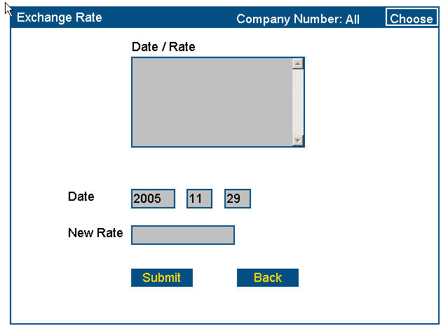
Click Submit.
Enter new rate.
Figure 3-1 Exchange Rate screen
- Enter the information as per the following table:
Table 3-1: Exchange Rate – Data Entry Fields
Field | Description
Date/Rate | Display box showing a list of the defined rates and the dates they were entered. The list is in ascending date order. This box is empty if no rate has been defined. If you enter the same date as in the previous entry, the new entry overwrites the previous one.
Date | Shows the current system date. You can edit the year, month and day values. Format YYYYMMDD.
New Rate | You enter the new rate here.  Format: 9.99

- Click Submit. You will see a message at the bottom of the screen:
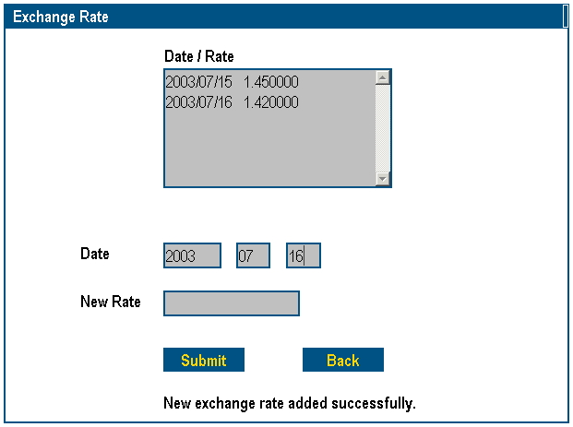
Exchange rate added successfully message.
Figure 3-2 New Exchange Rate

System Maintenance menu
Use the System Maintenance menu to configure the Casper Server for Casper eCommerce. You may view and set all the options that formerly were handled by the CasperServer.exe program. The System Maintenance menu consists of 9 pages:
- General
- Email
- E-Receipt
- Licensing via Email
- Easy License
- Auto Import
- Credit Card
- Fraud
- Taxes
Note: Pages 3 and 7-9 are used to configure Casper for the eCommerce feature and are described in this section. For pages 1-2, and 4-6, please refer to Part 2: Casper eRegister.

E-Receipt
Page 3 – E-Receipt allows you to configure the Casper Server to send automatic electronic receipts (e-Receipts) in response to successful credit card transactions made via Internet messages. You can configure a standardized email subject line and a standardized outgoing message. The Subject line is used on the outgoing message to the user once the transaction is authorized, and the outgoing message is incorporated into the electronic receipt that Casper sends.
For transactions made via email messages, separate electronic receipts are not issued. Instead, the receipt information is included in the standard confirmation email sent to the customer.
Procedure
- From the System Maintenance menu, select page 3 – E-Receipt from the drop-down menu. The E-Receipt page displays:
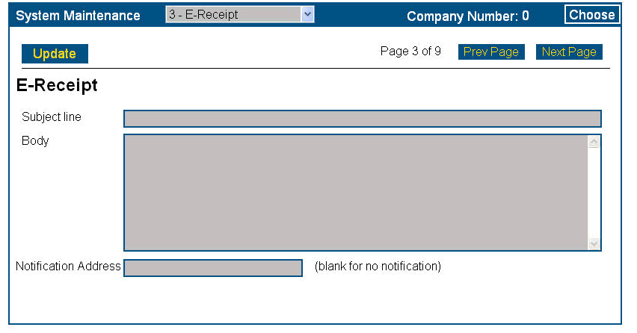
Figure 3-3 System Maintenance – E-Receipt page
- Enter the information as per the following table:
Table 3-2: E-Receipt – Data Entry Fields
Field | Description
Subject line | This is the outgoing free-form message.
Body | The message the Server will send to customers as a follow-up to a successful credit card transaction (e.g. “Thank you for buying the latest version of XYZ”). Format is free-form, with the exception that the text must include the characters <data> somewhere in the text area. When creating an electronic receipt, the Server replaces <data> with the financial information of the transaction.
Notification Address | The email address of the contact person in your company who needs to be notified when a credit card transaction takes place. Leave this field blank if you do not wish to receive notification.
Product Code | You can specify an email address for a particular Product Code, to notify the appropriate person. IN DEVELOPMENT, NOT AVAILABLE AS OF THE PUBLICATION OF THIS MANUAL.
- Click Update. The Server is now ready to issue receipts by e-mail. See the sample e-receipt below:

Thank you for your order!
$ 100.00 PRODUCT 1
$ 8.25 Ontario Provincial Sales Tax 8.25%)
$ 7.00 Canadian Goods and Services Tax 7.00%) ----------------------
$ 115.25 Total

Order Date: 2006-01-27
Site Code: D21F 9BB2 D6A1 089B DA
Site Key: D6208DF7869BD69FBE9BD62E47
Serial #: AAAAAAGG
Credit Card Ref. #: 00A_OK_TEST00

Please do not respond to this email. If you have questions, please contact the vendor of this program.
Figure 3-4 Sample e-Receipt

Credit Card Authorization
Page 7 – Credit Card allows you to select a charge method.
Procedure
- Log on to CasperWeb (see Part 2: Casper eRegister, Log on to CasperWeb).
- Go to the Main menu.
- From the SuperUser menu, click the System Maintenance link. The System Maintenance screen displays.
- Select page 7 – Credit Card from the drop-down menu:
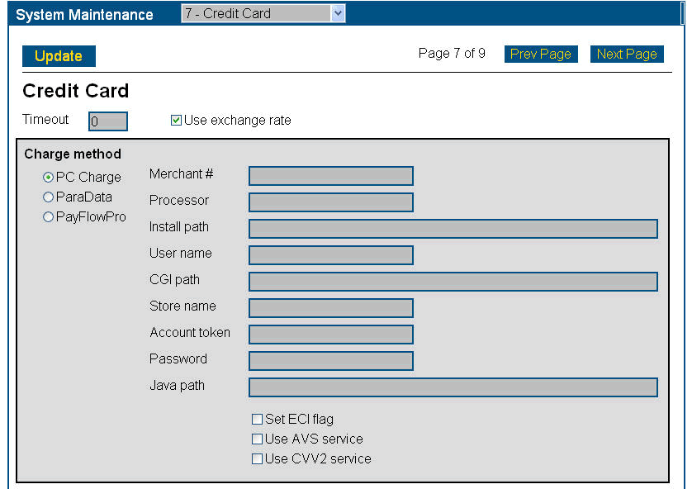
Figure 3-5 Credit Card screen
- Enter information according to the following table:
Table 3-3: Credit Card – Data Entry Fields
Field | Description
Time Out | Maximum waiting period (normally not greater than 999 seconds) allowed for approval of a credit card transaction. The recommended maximum wait is 60 seconds.
Use Exchange Rate | Check this box if you wish to have the Casper Server retrieve the rate currently set via the Exchange Rate option in CasperWeb (see Exchange Rate on page 188).
Charge Method | Click the button for the charge method you will be using.
Merchant # | The charge card merchant account number (open format) that you have been assigned by your processor. Consult the processor you plan to use to ensure the processor supports your merchant account number in a format recognized by the processor.
Processor | The code (format: X4, case-sensitive) used by your processor.
Install path | The absolute path of the directory containing the charge method software you have installed on your system.
User name | The name that you want to appear in your processor’s reports. For instructions on generating these reports, see the PCCharge product documentation.
CGI path | The absolute path to the directory where the CGI files are installed.
Store name | An identifier assigned to you by your processor (PCCharge, ParaData).
Account token | The security token for your account, given to you by the processor.
Password | The password for your account, given to you by the processor.
Java path | The path where the Java runtime is installed.
Set ECI flag | Electronic Commerce Indicator (ECI) flag that some processors require to be set if you are using Casper (PCCharge). Note this field is not required by Payflow Pro.
Use AVS service | Activates the Address Verification Service (AVS); used with PCCharge and ParaData to verify the Zip code for the billing address to reduce fraud.  Note this field is not required by ParaData.
Use CVV2 service | Activates Credit Card Verification Value #2 (CVV2); the number on the back of a credit card that is checked by PCCharge and by PayFlow Pro ParaData to reduce fraud.  Note this field is not required by ParaData.
- Click Update.

Fraud Protection
Page 8 – Fraud allows you to configure fraud protection for Casper. Casper recognizes two patterns that indicate a probability of fraudulent card usage:
- too many transactions occurring within a specified timeframe.
- too many declined transactions occurring within a specified timeframe.
You can configure Casper to deal with either or both patterns.
Procedure
- From the System Maintenance menu, select page 8 – Fraud from the drop-down menu. The Fraud Protection page displays:
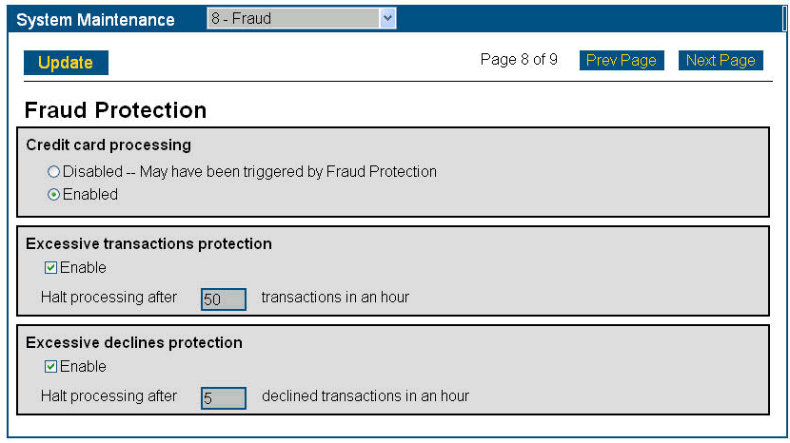
Figure 3-6 System Maintenance – Fraud Protection page
- Credit card processing: click on Enabled (the default) if you wish to monitor and control fraudulent credit card transactions.
- Excessive transactions protection: place a checkmark in Enable (the default) if you wish to activate the Casper feature to check for too many transactions occurring within a specified time period. In the Halt transactions box, enter the maximum allowable number of credit card transactions (default: 50) within a one-hour time span.
Note: If this number is exceeded, the Server will stop processing all credit card transactions and will automatically select the Disabled radio button under Credit Card Processing. To resume operations, you will need to click the Enabled radio button.
- Excessive declines protection: click on Enabled (the default) if you wish to activate the Casper feature to check for too many declined transactions occurring within a specified timeframe. In the Halt transactions box, enter the maximum allowable number of declined credit card transactions (default: 5) within any one-hour time span.
Note: If this number is exceeded, the Server will stop processing all credit card transactions and will automatically select the Disabled radio button under Credit Card Processing. To resume operations, you will need to click the Enabled radio button.
- Click Update to save your changes.

Tax Calculations
Page 9 – Tax allows you to configure the Casper Server to calculate sales taxes at the national and state or provincial levels. When configured for this function, the Server:
- identifies the product price from the Product Code record in CasperWeb (see
Part 2: eRegister, Product Code Browser, Modify Product Codes).
- calculates taxes accordingly
- adds the taxes to the price
- passes the total amount to the credit card processing module for processing (see Credit Card Authorization above).
Note: In order for the above processing to take place, the customer must have specified the applicable state (or province) and/or country abbreviations in the Electronic Purchase Wizard (see Part 4: Casper , Using the Credit Card Method).
Procedure
- From the System Maintenance menu, select page 9 – Taxes from the drop-down menu. The Taxes page displays:
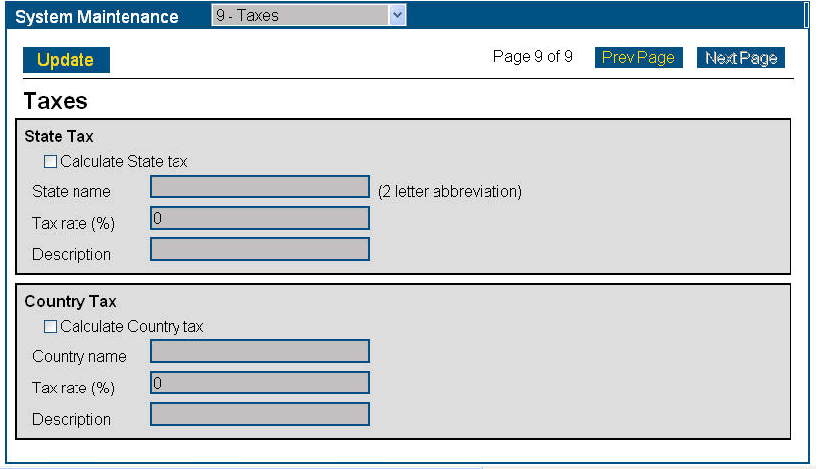
Figure 3-7 System Maintenance – Taxes page

- To calculate state or provincial sales tax, place a checkmark in the State Tax checkbox.
- In the State name field, type in an abbreviation for the state or province (format: X2).
Note: State name is required if you are calculating state or provincial sales tax.
- In the Tax rate % field, type in the applicable percentage of state or provincial tax (format: I2; required).
- In the Description field, type a description of the tax (free-form).
- To calculate national sales tax, check the Calculate Country tax checkbox.
- In the Country name field, type the name of the country (free-form; required if you are calculating national sales tax).
- In the Tax rate % field, type in the applicable percentage of national tax (format: I2; required).
- In the Description field, type a description of the tax (free-form).
- Click Apply, then Update to process the tax calculations.

Chapter 4: eCommerce Reports
Use CasperWeb to generate sales reports.
Ce
asperWeb’s reporting function includes a sales report, reported by Product Code on a day, week, month and year basis. See the following for steps for details of how to generate a sales report.
Procedure
- Go to the CasperWeb Main menu.
- Click the Reports link on the Admin menu. The Reports screen displays:
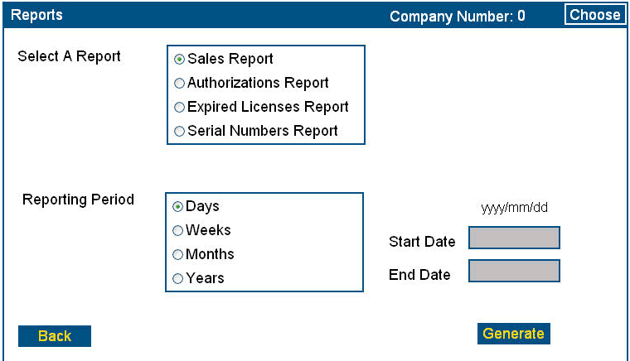
Select Sales report.
Enter reporting period start and end dates.
Click Generate.
Figure 4-1 Reports screen
- Click Generate. The applicable report is displayed, in this example, Sales reported on a daily basis:

Grouped by Product Code.
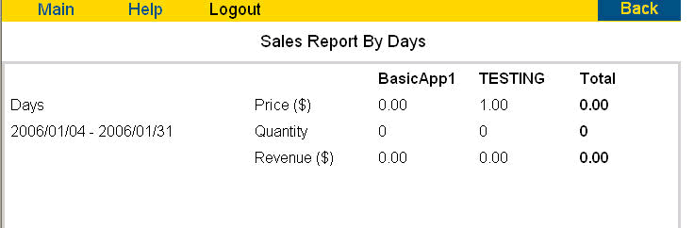
Figure 4-1 Sales by Day Report
- To print the report, right-click on the page and select the Print option.
Note: Some reports use a landscape orientation.
- Sales Reports generated on a weekly or monthly basis include:
- a total for each Product Code listed
- a subtotal of all Product Code sales by week
- a grand total
See the following example:
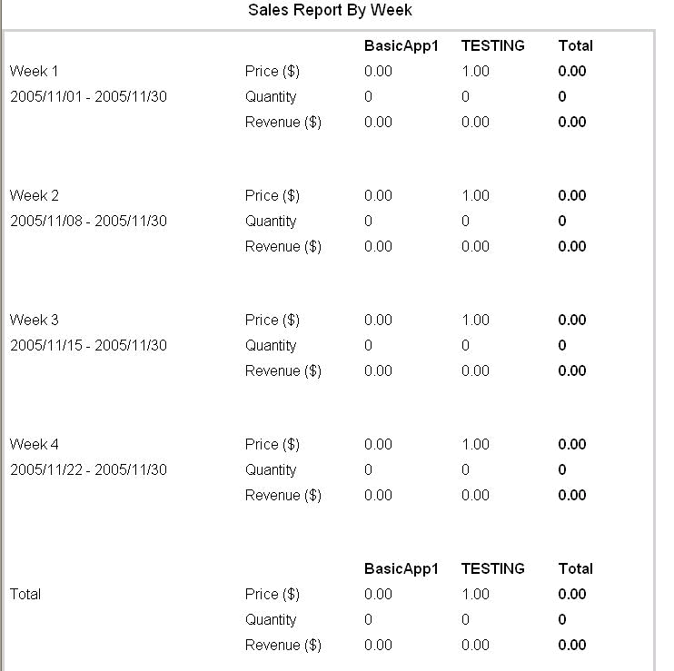
Figure 4-2 Sales by Week Report
Total sales.
Note: The price is reported as entered in the Price field in the View Product Code Browser screen.

Index
This index includes page references for significant occurrences of Casper topics and terms in Part 3.

Casper server
configure for credit cards 187
eCommerce configuration requirements 188
charge methods 187, 188
Client Wizard See Electronic Purchase Wizard
credit card
validity 188
credit card transaction
and customer order record 188
customer order record 188
eCommerce
and Casper server 187
charge methods 187
definition 179
functionality 179
functions 179
prerequisites 181
Electronic Purchase Wizard
appearance with eCommerce 180
exchange rate 188
and price 188
override 188
fraud
excessive declines 198
excessive transactions 198
patterns 197
fraud protection 197
grand total 202
license
purchase price 187
merchant account 187
online payment processing 187
Payflow Pro 187
PC Charge 187
Product Code
in reports 201
reports
by product code 201
by sales 201
sales report 201
daily 201
weekly/monthly 202
sales tax 199
system maintenance
functionality 190
menu 190
tax rate
national 200
state or provincial 200
testing
and company data 183
eCommerce functions 183
for eRegister 183

